Message Router Users Guide

INTRODUCTION
The Message Router is a light-weight messaging server meant to provide a reliable and efficient message-switching capability among a large number if dedicate clients. As of version 1.7.24 there is no security built into the server whatsoever. This is to reduce the overhead in performing message routing. The intent of this server is NOT to provide an all-purpose end-user switching service, but to provide a specialized message switching capabilities among automated clients which require a high message throughput rate.

BACKGROUND
During 2003, the DARPA Ultralog project was using Jabber in it’s Test and Integration Center (TIC) to perform message routing functions in support of it’s testing of the COUGAAR distributed agent framework. During that time they were using the public domain jabber server running on RedHat Linux 8.0. As the size of the distributed agent society grew, and as the complexity of the messages increased, the jabber server was soon unable to keep up with the demand. As a result we decided to create a message server that would be sufficient for the demands at hand without adding any unnecessary complexity. A simple binary protocol was developed and then an initial implementation was done in Ruby. To eliminate the memory overhead associated with the Ruby interpreter, a second version was developed in C++ to run on RedHat Linux. This is the version that this user’s guide is based upon.

OVERIVEW
The Message Router is a multi-threaded server that uses a dedicated socket for each client connection. Each connection is assigned two separate threads – one to read incoming messages and another to process outgoing messages. The message protocol is a binary protocol that is defined as follows:
- Eight byte header
  - 1st byte: length of ‘to’ field
  - 2nd byte: length of ‘from’ field’
  - 3rd byte: length of ‘thread id’ field
  - 4th byte: length of ‘subject’ field
  - 5th – 8th bytes: length of ‘body’ field
- Variable size data field – the size of this field is determined by the sum of the length values in the header.

The following table contains the commands that the server responds to:
Command | Response | Description
subject: connect  body: <name> | connected | creates a dedicated connection to the server
subject: disconnect | <none> | disconnects a client from the server (NOTE: if the client closes the socket this will also cause a disconnect on the server)
subject: list | <list of connected clients> | gets a list of connected clients that are delimited by a new line character
subject: register | registered | registers the client as a listener for other client online and offline events
subject: deregister | deregistered | deregister as a listener for client online and offline events
subject: validateConnections | <none> | causes the server to check all the existing connections to ensure that they are all still active by sending a ping message an waiting for a reponse.
subject: version | <version string> | gets the version of the server
subject: eavesdrop  body: target client name | eavesdrop enabled | Allows one client to eavesdrop on the messages to and from a target client.
subject: globaleavesdrop | globaleavesdrop enabled | Allows a client to eavesdrop on the messages to and from all the connected clients
subject: uneavesdrop  body: target client | eavesdrop disabled | Disables eavesdropping on the target client
subject: uneavesdropall | all eavesdroppers disabled | Disables all the eavesdroppers for the connected client.
subject: unglobaleavesdrop | globaleavesdrop disabled | Disables global eavesdropping for the connected client
subject: enable eavesdropping | eavesdropping enabled | Enable to the eavesdropping facility
subject: disable eavesdropping | eavesdropping enabled | Disables the eavesdropping facility
subject: enable error messages | error messages enabled | Enables the server to respond to erroneous server messages with an return error message
subject: disable error messages | error messages disabled | Prevents the server from responding to erroneous server messages with a return error message.
subject: get stats | <server statistics> | Gets a list of servers statistics such as total incoming/outgoing messages, message rates, etc
subject: reset stats | stats reset | Resets the message server statistics by zeroing out the incoming/outgoing message counters.
subject: get send queue stats | <send queue stats> | Returns the current size of each connections send queue
subject: get connection stats | <connection statistics> | Returns connection statistics for each connection
subject: get connection profiles | <connection profile info> | Returns the message routing profile for each connection
subject: set max send queue size  body: <size> | Max send queue size changed from <n> to <m> | Sets the maximum size of the send queue for each connection
subject: kill connection  body: <client name> | connection killed OR unable to kill connection | Allows a client to kill another client’s connection
subject: set log level <info|warn|debug|shout> | log level set to <INFO|WARN|DEBUG|SHOUT> OR unknown log level | Sets the level of the logging service
subject: enable logging | logging enabled | Enable the logging subsystem
subject: disable logging | logging disabled | Disables the logging subsystem
subject: log to file | logging to file | Directs the log messages to a file
subject: log to stdout | logging to stdout | Directs the log message to stdout
to: broadcast | broadcast a message to all connections | Broadcasts a message to all the current connections
subject: help | <list of server commands> | Returns a list of valid server commands

Command-line options:
Option | Description
-b | enable block reading This option will allow the server to read messages in pre-defined block sizes rather than reading one message at a time. This method can be more efficient when the message traffic consists of mainly small messages.
-i | enable logging at INFO level - All log messages are enabled
-w | enable logging at WARN level – WARN, DEBUG, SHOUT log messages are enabled
-d | enable logging at DEBUG level – DEBUG and SHOUT log messages are enabled
-s | enable logging at SHOUT level – only SHOUT messages are enabled
-r | disable duplicate connections – When this option is set, a client that tries to connect using an existing connection name will be refused. By default, if a client tries to connect using and existing connection name, the existing connection is disconnected and the new client is connected.
-e | enable eavesdropping – Enables the eavesdropping system
-m | enable error messages – Enables the server to send error messages back in response to invalid server commands. By default the capability is disabled to prevent automated clients from inadvertently generating messages storms by not properly handling the return error message.
-h | help – prints this list of options

RUNNING THE SERVER
The message router may be run in several ways: the simplest way is to merely invoke it as an application. In this case, all log messages go to console since the logging subsystem sends everything to stdout. At the TIC, we package up the message router in an RPM that installs it as a Linux service so that it can be started and stopped with the service command. This RPM contains a shell script that launches the message router and redirects the stdout to /var/log/messagerouter.log.

MESSAGE ROUTER CLIENT
A java client is available for interacting with the message server. This client is also available from http://cougaar.org/projects/message-router. This is a simple client that allows users to connect to the server and monitor the activity. At the TIC, most of the activity on the message routers is the result of automated clients.
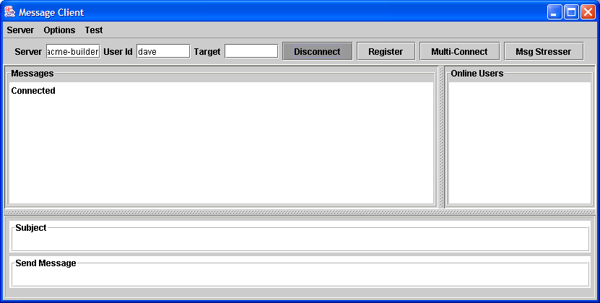

OTHER VERSIONS
Aside from the Linux version of the message router, a Ruby version also exists (as has been mentioned before) and a Windows version as well. The Windows version is implemented in C# and requires the .NET runtime to be installed in order to run. The Windows version is also available at http://cougaar.org/projects/message-router.

